**REAL-TIME EMBEDDED SYSTEM**

**EXPERIMENT**

**Dual-Mode Real-Time Cap Sorting System Using Arduino Uno**

Name: NAVARRO, ROD GERYK C.

Course/Section: CPE161P-4/C1

Group No.: N/A

CYREL O. MANLISES, PH.D.

Instructor

**OBJECTIVES**

* **Develop a dual-mode sorting system**  
  Create a sorting machine that can operate in two modes:
* *Automatic Mode:* Sorts caps automatically based on their color.
* *Manual Mode:* Allows the user to control sorting through a 4x4 keypad.
* **Integrate servo motors for sorting operations**  
  Use two servo motors to:
* Pick caps from the storage and position them for color detection.
* Route the identified caps to their respective containers.
* **Implement color detection system**  
  Use a color sensor to identify and sort three different colored caps accurately.
* **Display sorting information on an LCD**  
  Show the number of caps sorted per color on an LCD screen in real-time.
* **Ensure smooth user interaction**  
  Allow users to easily switch between automatic and manual modes at the start using the keypad.
* **Achieve efficient and accurate sorting**  
  Make sure the system sorts caps correctly and keeps track of the count without errors.
* **Test and optimize system performance**  
  Evaluate the system's speed, accuracy, and reliability in both modes, and make improvements as needed.

**DISCUSSION**

This project focuses on building a real-time sorting machine using an Arduino Uno. The machine is designed to sort plastic bottle caps based on their color. It has two modes of operation: automatic and manual. In automatic mode, the machine sorts the caps on its own, while in manual mode, the user controls the sorting process using a 4x4 keypad. At the start of the project, the user can choose which mode to use.

The sorting process begins with a servo motor that picks up caps from the storage area. This motor rotates and positions each cap in front of a color sensor. The color sensor identifies the color of the cap, which can be one of three colors. After identifying the color, the cap is dropped to a second layer. Here, a second servo motor routes the cap to the correct container based on its color. This ensures that caps of the same color are collected in the same container.

To keep track of the sorting process, an LCD display is used. It shows the number of caps sorted for each color in real-time. This helps users monitor the machine’s performance and know how many caps have been sorted for each category.

The 4x4 keypad allows the user to control the machine manually in manual mode. By pressing specific buttons, the user can pick, identify, and sort the caps themselves. This mode gives flexibility if the user wants to have more control over the sorting process.

This project combines hardware components like servo motors, a color sensor, an LCD display, and a keypad with Arduino programming to create an efficient and flexible sorting machine. It can be used in small recycling centers or educational setups to demonstrate the basics of automation and embedded systems. The machine aims to be accurate, user-friendly, and adaptable to different sorting needs.

**EXPERIMENTS**

**1. Real-Time Scoreboard for a Basketball Game**

In this experiment, a **4-digit seven-segment display (SSD)** was used to keep track of scores for two teams. Buttons were assigned specific functions like adding points, switching teams, and decreasing scores. Similarly, in the sorting machine project, the **LCD display** will serve as the scoreboard, showing the number of caps sorted per color. The concept of tracking scores in real-time directly translates to counting the sorted caps accurately. Additionally, just as LEDs indicated which team was being scored, LEDs could be integrated to indicate which color is currently being sorted.

**2. Real-Time Traffic Light**

The traffic light experiment utilized an **ultrasonic sensor** to detect vehicles violating stop signals, a **buzzer** to alert violations, and LEDs to represent different signals. The concept of managing signals and timers in the traffic light experiment helps structure the timing and routing logic in the sorting process. For example, just as LEDs showed stop, ready, and go signals, LEDs can indicate different sorting phases (picking, identifying, and routing).

**3. Weather Monitoring System**

The weather monitoring experiment used a **DHT11 sensor** to display temperature and humidity readings on an **LCD screen**. This setup parallels the sorting machine, where the **LCD** will display the number of caps sorted per color. The idea of real-time data collection and display from the sensor translates into real-time color detection and count updates in the sorting machine. The integration of sensors and live data output in this experiment mirrors how the color sensor’s readings will be processed and displayed.

**4. Appliance Controller**

In this experiment, a **4x4 keypad** was used to control various appliances like motors, buzzers, and LEDs. This directly connects to the **manual mode** of the sorting machine, where the user will use a **4x4 keypad** to control the sorting process manually. The keypad allows for functions like picking a cap, identifying the color, and directing it to the correct container. The concept of controlling multiple devices with a single keypad simplifies the user interface in the sorting machine.

**5. Real-Time Vault System**

The vault system experiment included a **password mechanism** using switches (or a keypad) and a **servo motor** to open and close the vault. This concept relates to the sorting machine in terms of **security and control**. The **servo motors** used in the vault to manage access will be applied in the sorting machine to control the movement of caps from storage to their respective containers. The **timing logic** used to automatically close the vault after a set time can be adapted to automate the cap dropping mechanism after color identification.

**LIST OF MATERIALS**

* **Arduino Uno** – The main microcontroller to control all components.
* **2 Servo Motors** –

**Servo 1:** Picks up caps from the storage and moves them to the color sensor.

**Servo 2:** Routes the caps to their respective containers based on color.

* **Color Sensor (e.g., TCS3200 or TCS34725)** – Identifies the color of each cap.
* **LCD Display (16x2)** – Displays the number of caps sorted per color.
* **4x4 Keypad** – Allows manual control of the sorting process.
* **Colored Caps (3 Colors)** – The items to be sorted (e.g., red, green, blue caps).
* **LEDs (Optional)** – Indicate different states like sorting status or errors.
* **Resistors (220Ω, 10k)** – For current limiting and pull-down configurations.
* **Jumper Wires** – To connect all components on the breadboard.
* **Breadboard**– For circuit assembly and prototyping.
* **Sorting Containers (3 Pieces)** – Separate containers for each color.
* **Power Supply (5V or USB)** – To power the Arduino and components.
* **Laptop with Arduino IDE** – For programming and uploading the code.

**BLOCK DIAGRAM**

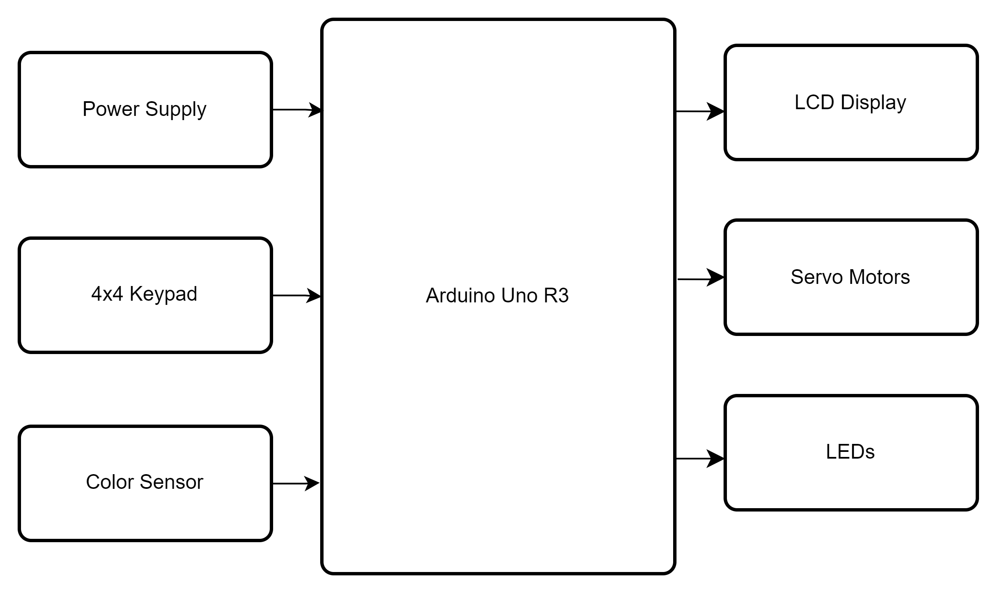

**FLOWCHART**

